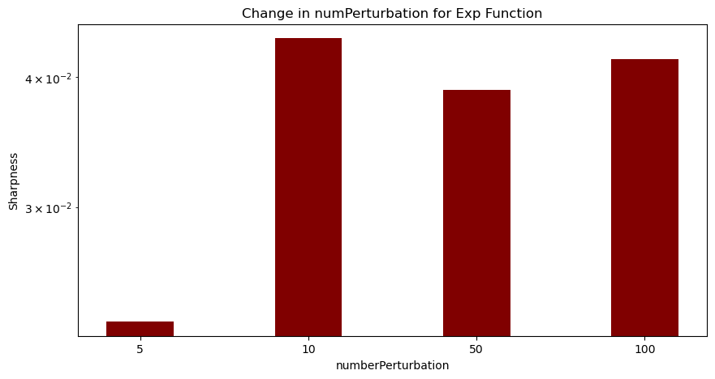

This bar graph represents the change in the number values. Changing the number perturbation value by a specific number allows you to specify how much change you want to put on the input values. Being able to set an exact amount of perturbation can help keep accurate results. How much you change the number value by can impact the stability and sharpness of the function. The number perturbation goes from low values to higher ones. In this example, the exponent operator increases dramatically in the first change but later becomes stable.

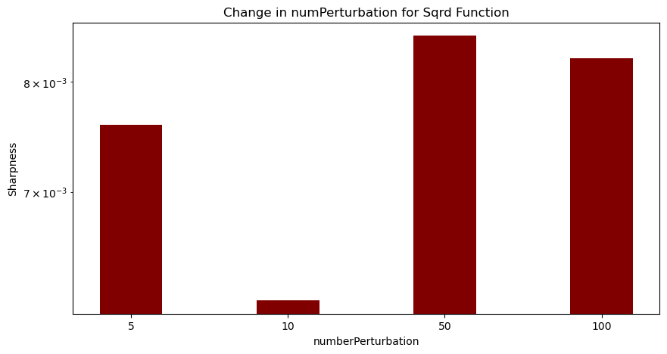

This graph shows the different number perturbations for the squared operator. It follows an oscillating pattern. When making large changes to the input values, the sharpness increases and decreases in a wave like pattern because of how big the changes are.

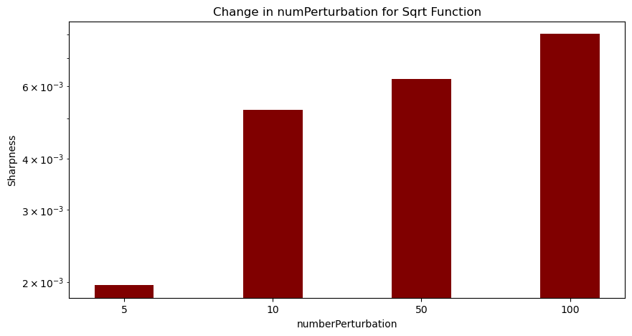

For this square root bar graph, there is an increase throughout the changes for number perturbation.

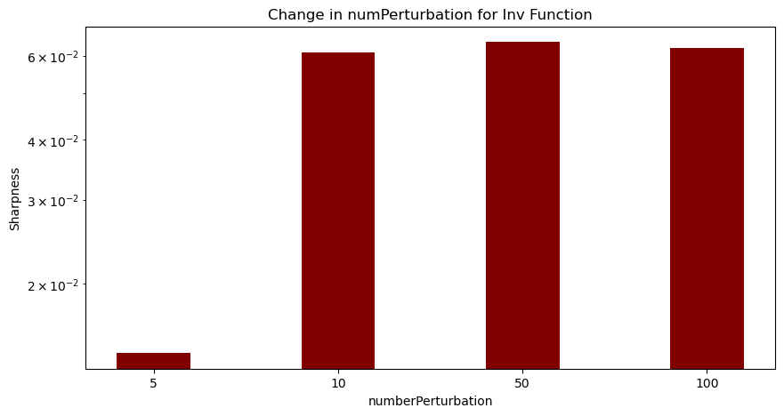

This bar graph shows the change in number perturbation for the inverse operator. It starts by a drastic increase and then becomes stable later on.

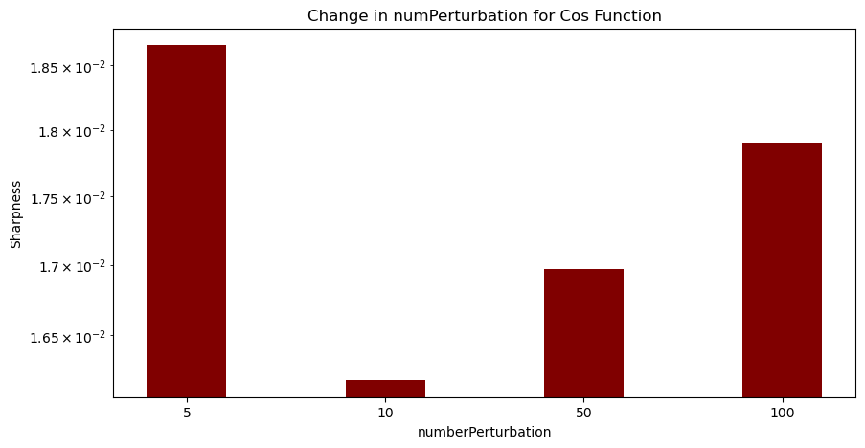

This bar graph shows the change in number perturbation for the cosine operator, which follows a “u-shaped” trend.

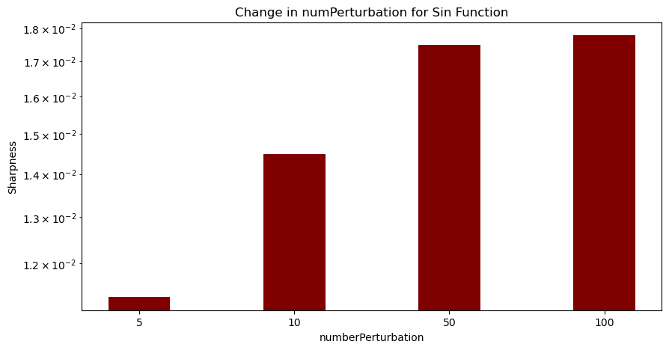

Like the square root operator graph, the graph for the sin operator also increases all the way.

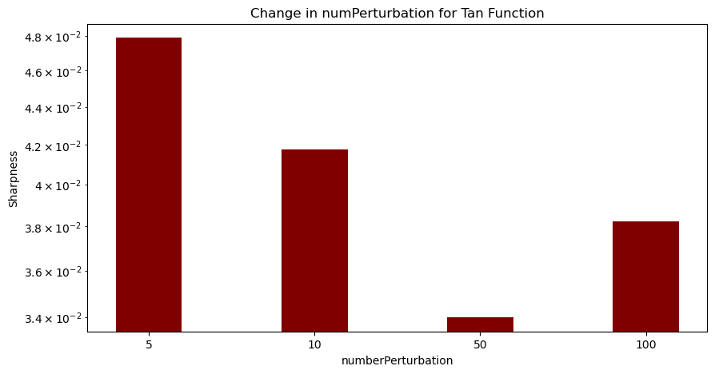

This graph shows the trend for the tangent operator. It starts off as decreasing then goes back up towards the end.

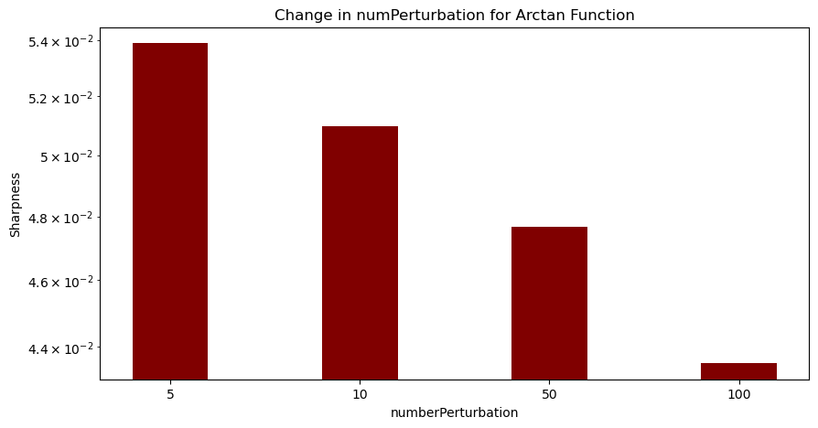

Opposite to the sin and square root operators, the sharpness bar graph for arctan decreases as the number perturbations increase.

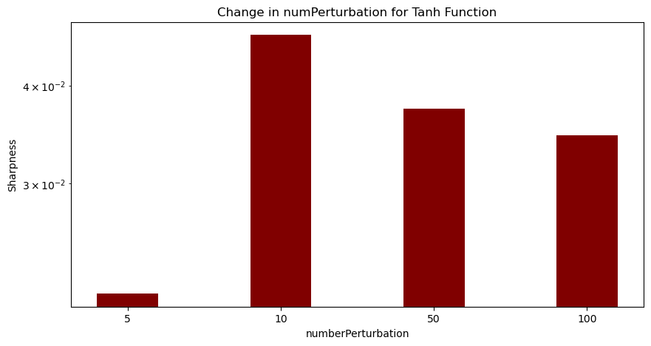

This graph shows the trend for the hyperbolic tangent operator. It increases in the first number perturbation change but switches to decreasing for the rest.

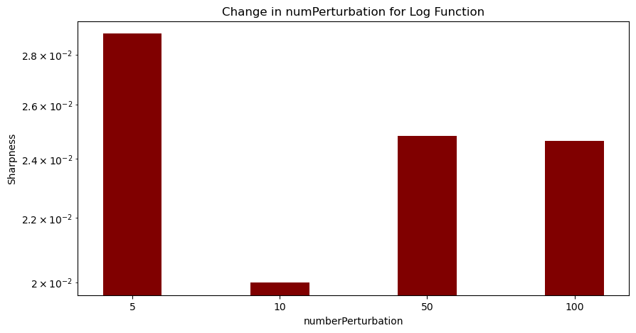

This bar graph shows the trend for a logarithmic operator. The trend decreases dramatically in the first switch but it gets stable after.